Bahria University,

Karachi Campus



LAB EXPERIMENT NO.

___02___

LIST OF TASKS

|  |  |
| --- | --- |
| TASK NO | OBJECTIVE |
| **01** | Implement on page reload animation for mobile and text. Headings should contain text shadow. Make sure to use gradients . |
| **02** | **Implement open Laptop on hover animation as discussed and upon click navigate to products cards section.** |
| **03** | **Create cards layout. Use flex to make them responsive .For each card there must be a box shadow ,use border radius property for curved borders. By default images should be black and white and on hover they must turn in colored images. Rest of on hover animmations can be applied on text** |
| **04** | **Implement first web Page** |
| 05 | Implement second web Page |

Submitted On

05-10-2023

(Date: DD/MM/YY)

**Task 01:** Implement on page reload animation for mobile and text. Headings should contain text shadow. Make sure to use gradients .

**Solution:**

**Index.html:**

<header>

<h1 class="animated-heading">Computer Zone</h1>

</header><ul class="horizontal-list"><li><a href="#">Home</a></li><li><a href="#">Product</a></li><li><a herb="#">Laptop</a></li><li><a href="#">Graphic Card</a></li><li><a href="#">Monitors</a></li><li><a href="#">Painters</a></li><li><a href="#">Speakers</a></li><li><a href="#">Mobile</a></li><li><a href="#">Consoles</a></li><li><a href="#">Apple</a></li></ul><div class="product-container"><div class="product"><h2>iPhone</h2><img height="350vh" width="200vw" src="" alt="iPhone"></div><div class="product"><h2>Apple Watch</h2><img height="350vh" width="200vw" src="" alt="Apple Watch"></div><div class="product"><h2>MacBook</h2<img height="350vh" width="200vw" src="" alt="MacBook"></div><div class="product"><h2>iPad</h2><img height="350vhwidth="200vw" src="" alt="iPad"></div><div class="product"><h2>Apple Pencil</h2><img height="350vh" width="200vw" src="" alt="Apple Pencil"></div>

**Output:**

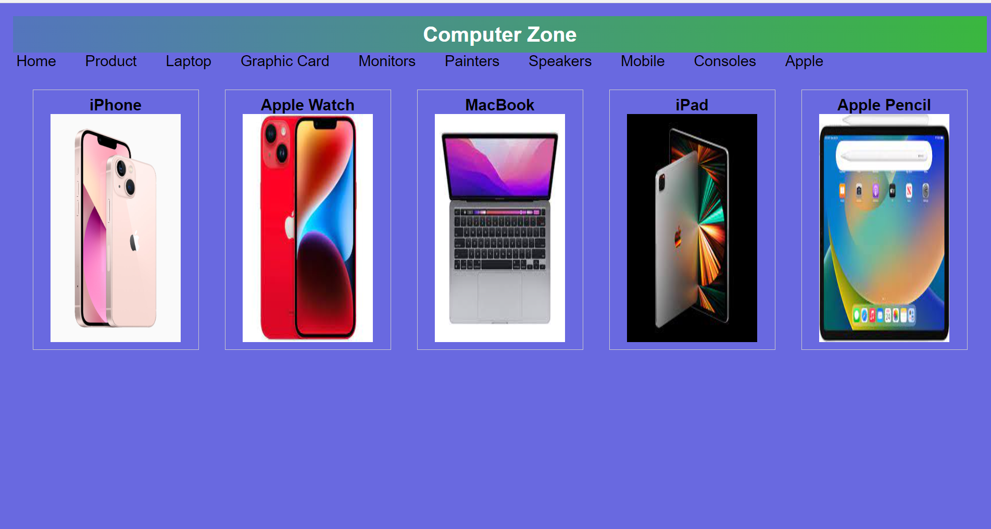

**Task 03:** Create cards layout. Use flex to make them responsive .For each card there must be a box shadow ,use border radius property for curved borders. By default images should be black and white and on hover they must turn in colored images. Rest of on hover animmations can be applied on text

**Solution:**

**Index.html**

<!DOCTYPE html><html lang="en"><body><div class="container"><div class="json"><img src="shoaib.PNG" alt="myImage" width="100vw" height="100vh"><h2>Shoaib Akhter</h2><p>CEO & Founder</p><p>Bahria University</p><div class="icons"><i class="fa fa-instagram" aria-hidden="true"></i><i class="fa fa-github" aria-hidden="true"></i><i class="fa fa-twitter" aria-hidden="true"></i><i class="fa fa-facebook" aria-hidden="true"></i></div><button>Contact</button></div><div class="jon"><img src="shoaib.PNG" alt="myImage" width="100vw" height="100vh"><h2>Shoaib Akhter</h2><p>CEO & Founder</p><p>Bahria University</p><div class="icons"><i class="fa fa-instagram" aria-hidden="true"></i><i class="fa fa-github" aria-hidden="true"></i><i class="fa fa-twitter" aria-hidden="true"></i><i class="fa fa-facebook" aria-hidden="true"></i></div><button>Contact</button></div><div class="nick"><img src="shoaib.PNG" alt="myImage" width="100vw" height="100vh"><h2>Shoaib Akhter</h2><p>CEO & Founder</p><p>Bahria University</p><div class="icons"><i class="fa fa-instagram" aria-hidden="true"></i><i class="fa fa-github" aria-hidden="true"></i><i class="fa fa-twitter" aria-hidden="true"></i><i class="fa fa-facebook" aria-hidden="true"></i></div><button>Contact</button></div><div class="joy"><img src="shoaib.PNG" alt="myImage" width="100vw" height="100vh"><h2>Shoaib Akhter</h2><p>CEO & Founder</p><p>Bahria University</p><div class="icons"><i class="fa fa-instagram" aria-hidden="true"></i><i class="fa fa-github" aria-hidden="true"></i><i class="fa fa-twitter" aria-hidden="true"></i><i class="fa fa-facebook" aria-hidden="true"></i></div><button>Contact</button></div></div><h1>Using Pure HTML , CSS</h1></body></html>

**Style.css**

body{margin: 0;padding: 0;}.container{display: flex;flex-wrap: wrap;justify-content: center;align-items: center;gap: 50px;background-color: aquamarine;height: 95vh;flex-direction: row;}.json,.jon,.nick,.joy{width: 15vw;height: 50vh;text-align: center;border: 3px solid green;border-radius: 30px;background-color: aliceblue;padding-top: 20px;}img{border-radius: 50%;}button{border-radius: 20px;background-color: black;color: white;width: 10vw;height: 5vh;}h1{text-align: center;background-color: gray;color: white;margin: 0;}

**Output:**

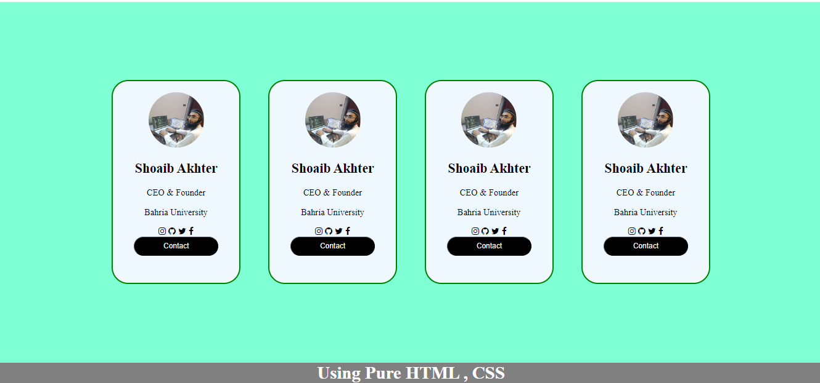

**Task 04:** Implement this web Page

**Solution:**

**index.html:**

<div class="blue-color"><div class="heading" ><h1 > <span>COMPUTER</span> <span>ZONE</span> </h1></div><div class="navbar"><ul><li><a href="/index.html" style="color: rgb(25, 25, 234); text-decoration:underline;" >Home</a></li><li><ahref="">Product</a></li><li><a href="">Laptop</a></li><li><a href="">Graphics Card</a></li><li><a href="">Monitors</a></li><li><a href="">Printers</a></li><li><a href="">Speakers</a></li><li><a href="">Mobiles</a></li><li><a href="">Consoles</a></li><li><a href="">Apples</a></li></ul> </div></div><div class="yellow-color"><div class="container"><div class="carousal"><div class="carousal-container"><h1>IPHONE XS MAX</h1><p>Released 2018, September</p><p>64/54 storage</p> </div><div class="carousal-image"><img src="./mobile.png" alt="mobile" width="60%" height="80%"> </div></div><div class="bg"></div></div></div>

**style.css:**

h1 {text-align: center; }h1 span:nth-child(1) {font-size: 40px;

font-weight: bold;color: white;}h1 span:nth-child(2) {background-color: yellow;color: black;border: 2px solid black;}

.navbar{background-color: rgb(198, 196, 196);height: 5vh;}.navbar ul{list-style: none; padding: 0 margin: 0; text-align: center;}.navbar li{ display: inline-block; margin-right: 40px;}.navbar li a{ text-decoration: none;font-size: 25px; color: #4f4e4e;}.container,.heading{ background-color: blue;}.carousal{ display: flex; background-color: #a6a6a6; justify-content: center; height: 80vh; border-bottom-right-radius: 200px;}.carousal-container{ width: 50%; text-align: center; line-height: 8px; margin-top: 60px;}.carousal-container h1{font-size: 50px;}.carousal-image{width: 50%;}.bg{ height: 5vh; background-color: blue;}.container{margin-right: 20px;}.blue-color{ background-color: blue; border-radius: 20px;}.heading,.navbar{margin-right: 20px;}.yellow-color{background-color: yellow;}

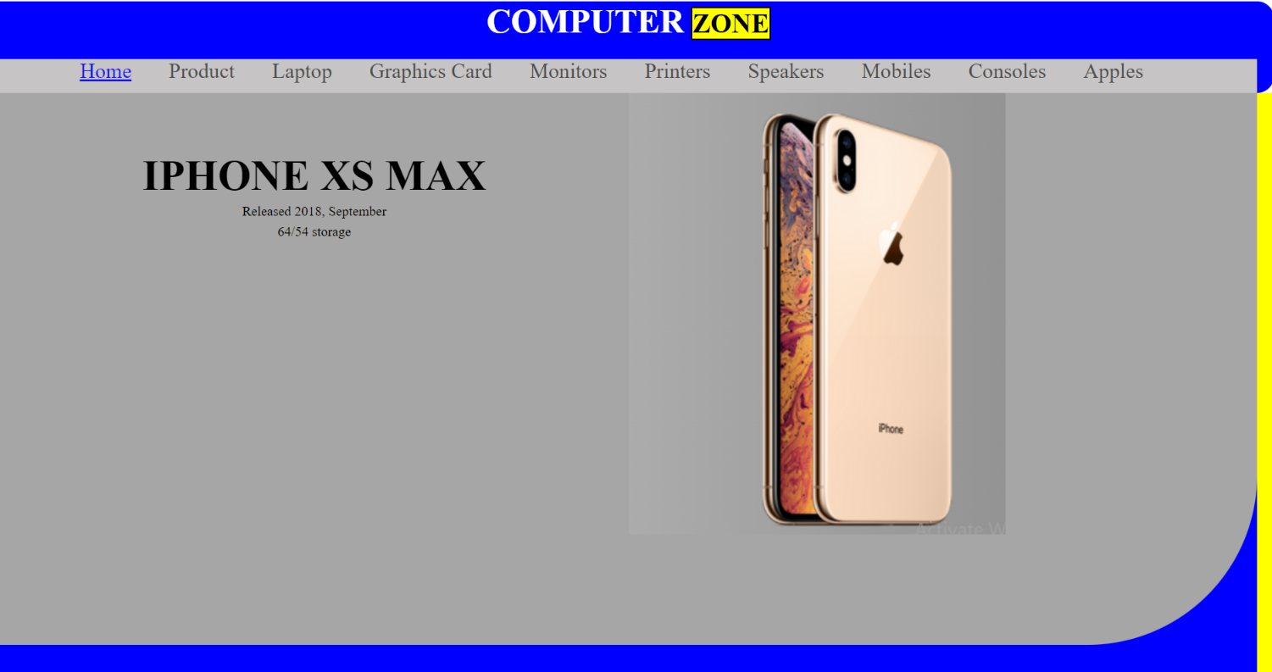**Output:**

**Task 05:** Implement this web Page

**Solution:**

**index.html:**

<body><div class=scroll-container><div class=content><div class=heading><h1> <span>COMPUTER</span> <span>ZONE</span> </h1></div><div class=navbar><ul><li><a href>Home</a></li><li><a href>Product</a></li><li><a href>Laptop</a></li><li><a href>Graphics Card</a></li><li><a href>Monitors</a></li><li><a href>Printers</a></li><li><a href>Speakers</a></li><li><a href>Mobiles</a></li><li><a href>Consoles</a></li><li><a href=/index.html style=color:#1919ea;text-decoration:underline>Apples</a></li></ul></div><div class=yellow-color><div class=container><div class=iphone><div class=iphone-first-div><div class=iphone-heading></div><h1>iPhone</h1></div></div><div class=iwatah><div class=macbook-border><div class=iwatch-first-div><h1>iWatches</h1></div></div></div><div class=macbook><div class=macbook><div class=macbook-first-div><h1>MACEBOOK</h1></div></div></div><div class=ipad><div class=ipad-first-div><h1>iPad</h1></div></div></div></div></body></html>

**style.css:**

: flex;justify-content: center;align-items: center;height: 80vh;gap: 60px;}.iphone-first-div{background-image: linear-gradient(to bottom right,yellow ,blue );border-radius: 20px;width: 12vw;height: 50vh;border:7px solid black;background-position:50% 50% ;transition: all 2s ease;}.iphone-first-div:hover{background-image: linear-gradient(to bottom right,blue ,yellow );}.iphone-heading{height: 2vh;width: 4vw;background-color: black;border-radius: 10px;margin-left: 60px;margin-bottom: 130px;}.iphone-first-div h1{color: aliceblue;font-size: 40px;font-weight: bold;}.iwatch-first-div{background-image: linear-gradient(to bottom right,yellow ,blue );border-radius: 40px;width: 15vw;height: 30vh;border:3px solid black;background-position:50% 50% ;transition: all 2s ease;}.iwatch-first-div:hover{background-image: linear-gradient(to bottom right,blue ,yellow );}.macbook-border{border-radius: 40px;/* border: 4px solid white; */}.iwatch-first-div h1{color: alicebluefont-size: 40px;font-weight: bold;margin-top: 80px;}.ipad-first-div{background-image: linear-gradient(to bottom right,yellow ,blue );border-radius: 20px;width: 15vw;height: 50vh;border:7px solid black;background-position:50% 50% ;transition: all 2s ease;border-top-width: 20px;border-bottom-width: 20px;}.ipad-first-div:hover{background-image: linear-gradient(to bottom right,blue ,yellow );}.ipad-first-div h1{color: aliceblue;font-size: 60px;font-weight: bold;margin-top: 130px;}. right,blue ,yellow );}.macbook-first-div h1{ color: aliceblue; font-size: 40px; font-weight: bold; margin-top: 80px;}

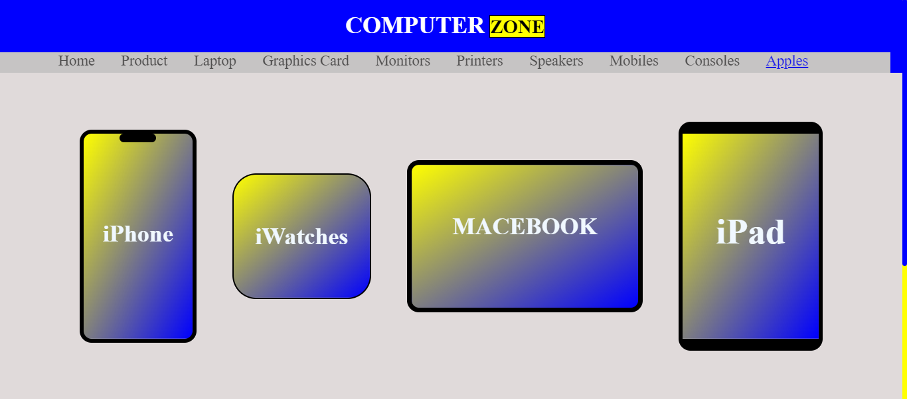**Output:**